## You

Are gorillas monkeys?

## Copilot

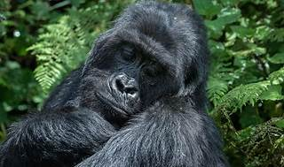

No, gorillas are not monkeys. Gorillas belong to a different group of primates known as **apes**. This group also includes humans, chimpanzees, bonobos, orangutans, and gibbons[^1^](https://leozoo.org/are-gorillas-monkeys/)[^2^](https://mrcsl.org/gorilla-monkey/).

Here are some key differences:

* **Classification**: Gorillas are classified as apes in the family Hominidae, while monkeys belong to various other families within the primate order[^2^](https://mrcsl.org/gorilla-monkey/).
* **Physical Traits**: Gorillas are generally larger and heavier than monkeys. They also lack tails, which most monkeys have[^3^](https://thisvsthat.io/gorilla-vs-monkey).
* **Behavior**: Gorillas are predominantly ground-dwelling, whereas many monkeys are more arboreal (tree-dwelling)[^4^](https://en.wikipedia.org/wiki/Gorilla).

If you have any more questions about gorillas or other primates, feel free to ask! 🦍

### Learn more:

1. [leozoo.org](https://leozoo.org/are-gorillas-monkeys/)
2. [mrcsl.org](https://mrcsl.org/gorilla-monkey/)
3. [thisvsthat.io](http://thisvsthat.io)
4. [en.wikipedia.org](http://en.wikipedia.org)
5. [medium.com](http://medium.com)
6. [www.britannica.com](http://www.britannica.com)
7. [www.gettyimages.com](http://www.gettyimages.com)